Pastry Bakery

Project by Brigett Hurley

10/11/2018

# Movie

Images audio modern

## Project Movie Udacity

This is a movie images with audio in neon half way through is modern.

There would numerous images of a movie pastry bakery project 2018.

NEWS

Paris: Make perfect French macarons and meringues in baking class

September 19, 2013 | By Mary Forgione, Daily Deal and Travel Blogger

Bake a little, eat a little and learn a lot about food, wine and French pastries in a class for English speakers offered by Paris-based Le Foodist. Participants learn the basics of authentic pastry skills in baking sessions that are part storytelling, part tasting and part technique. Sweet Stories at Le Foodist starts with the task of preparing pate-a-choux, the pastry used in eclairs, cream-puffs and the like. From there, it's making pastries, then sitting down to a tea to sample the creations.

L.A. pastry chef Waylynn Lucas talks Bravo's 'Eat Drink Love'

September 5, 2013 | By Yvonne Villarreal

The gourmet doughnut has finally gotten the Bravo treatment -- or, at least, its maker has. Waylynn Lucas is the co-owner of West Hollywood-based Fonuts, the 3rd Street doughnut shop she and Nancy Truman opened in 2011. The curly-haired pastry chef, who has worked for several big name Los Angeles restaurants and served as the executive pastry chef under Jose Andres at Bazaar, is in the midst of adding "Bravo-lebrity" to her resume as one of the stars of "Eat Drink Love. " Already finding success in the food competition genre, the network is now mixing foodie culture with its bread-and-butter formula:

If there’s one thing that best sums up Phoenix’s bakery scene, it has to be “so many bakeries, so little time.” That’s because down most major streets, around many bustling corners, and tucked into cozy neighborhoods are sweet spots where the best loaves, pastries, cookies, pies and so much more are made. If you’re looking for a decadent treat, here are ten Phoenix bakeries that rise to the occasion.

To say this popular bakery and restaurant captures the true “essence” of fresh-baked goodness is an understatement. Owner Eugenia Theodosopoulos has mastered the art of French pastry, which can be seen—and tasted—in her award-winning macarons. She learned to make the quintessential French treat at the prestigious École Lenôtre in Paris. The cookies are ethereal and airy, but it’s the filling that will get you every time. From espresso, to French chocolate, to raspberry rose, Theodosopoulos’ macarons are a true work of art.

gredients

Cupcakes:

1 1/2 cups self-rising flour

1 1/4 cups all-purpose flour

1 cup (2 sticks) unsalted butter, softened

2 cups sugar

4 large eggs, at room temperature

1 cup milk

1 teaspoon vanilla extract

Icing:

Vanilla Buttercream, recipe follows

Vanilla Buttercream:

1 cup (2 sticks) unsalted butter, softened

6 to 8 cups confectioners' sugar

1/2 cup milk

2 teaspoons vanilla extract

Directions

Watch how to make this recipe.

Icing:

Preheat oven to 350 degrees F.

Line 2 (1/2 cup-12 capacity) muffin tins with cupcake papers.

In a small bowl, combine the flours. Set aside.

In a large bowl, on the medium speed of an electric mixer, cream the butter until smooth. Add the sugar gradually and beat until fluffy, about 3 minutes. Add the eggs, 1 at a time, beating well after each addition. Add the dry ingredients in 3 parts, alternating with the milk and vanilla. With each addition, beat until the ingredients are incorporated but do not over beat. Using a rubber spatula, scrape down the batter in the bowl to make sure the ingredients are well blended. Carefully spoon the batter into the cupcake liners, filling them about 3/4 full. Bake for 20 to 25 minutes, or until a cake tester inserted into the center of the cupcake comes out clean.

Cool the cupcakes in tins for 15 minutes. Remove from the tins and cool completely on a wire rack before icing.

Vanilla Buttercream:

Place the butter in a large mixing bowl. Add 4 cups of the sugar and then the milk and vanilla. On the medium speed of an electric mixer, beat until smooth and creamy, about 3 to 5 minutes. Gradually add the remaining sugar, 1 cup at a time, beating well after each addition (about 2 minutes), until the icing is thick enough to be of good spreading consistency. You may not need to add all of the sugar. If desired, add a few drops of food coloring and mix thoroughly. (Use and store the icing at room temperature because icing will set if chilled.) Icing can be stored in an airtight container for up to 3 days.

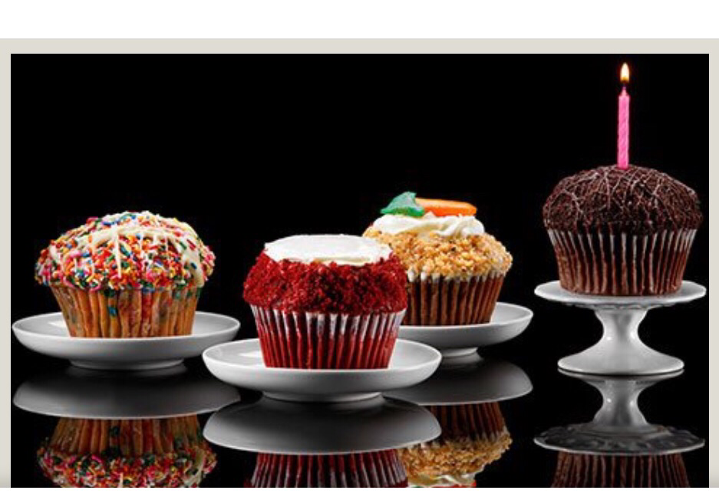

This is a movie project Pastry Bakery, Udacity, Nanodegree.

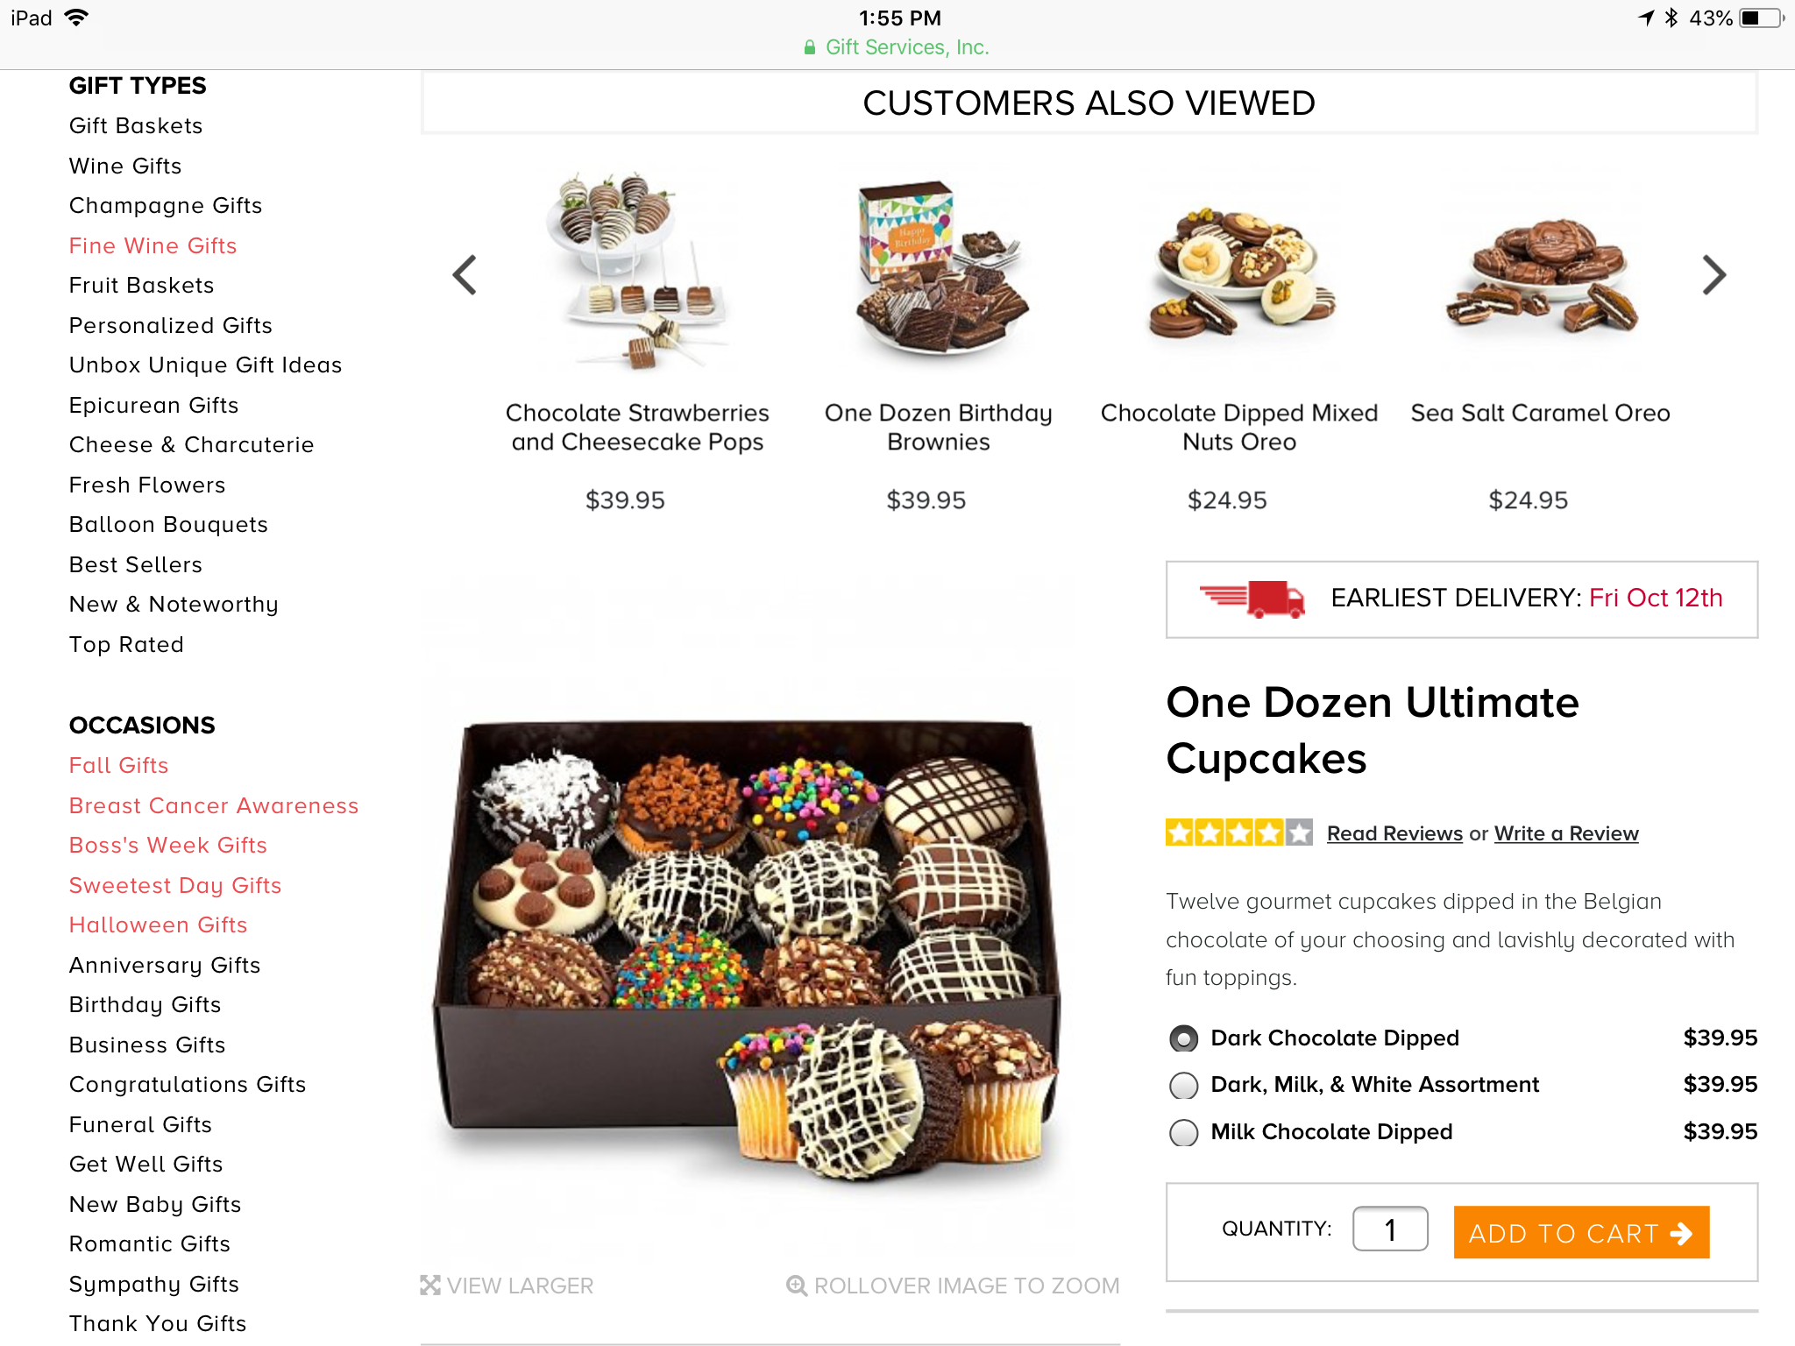

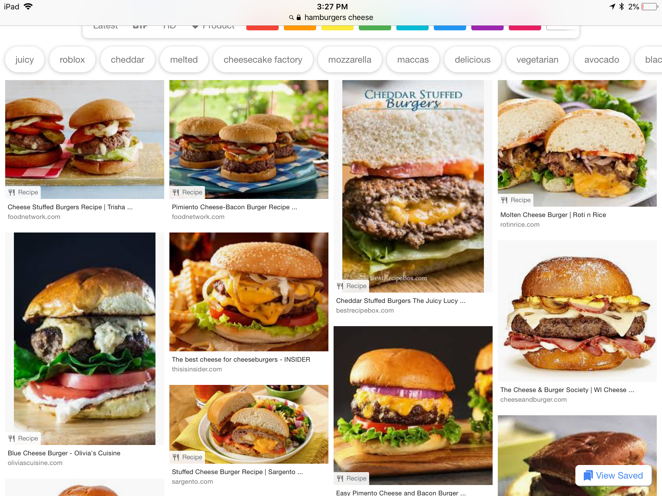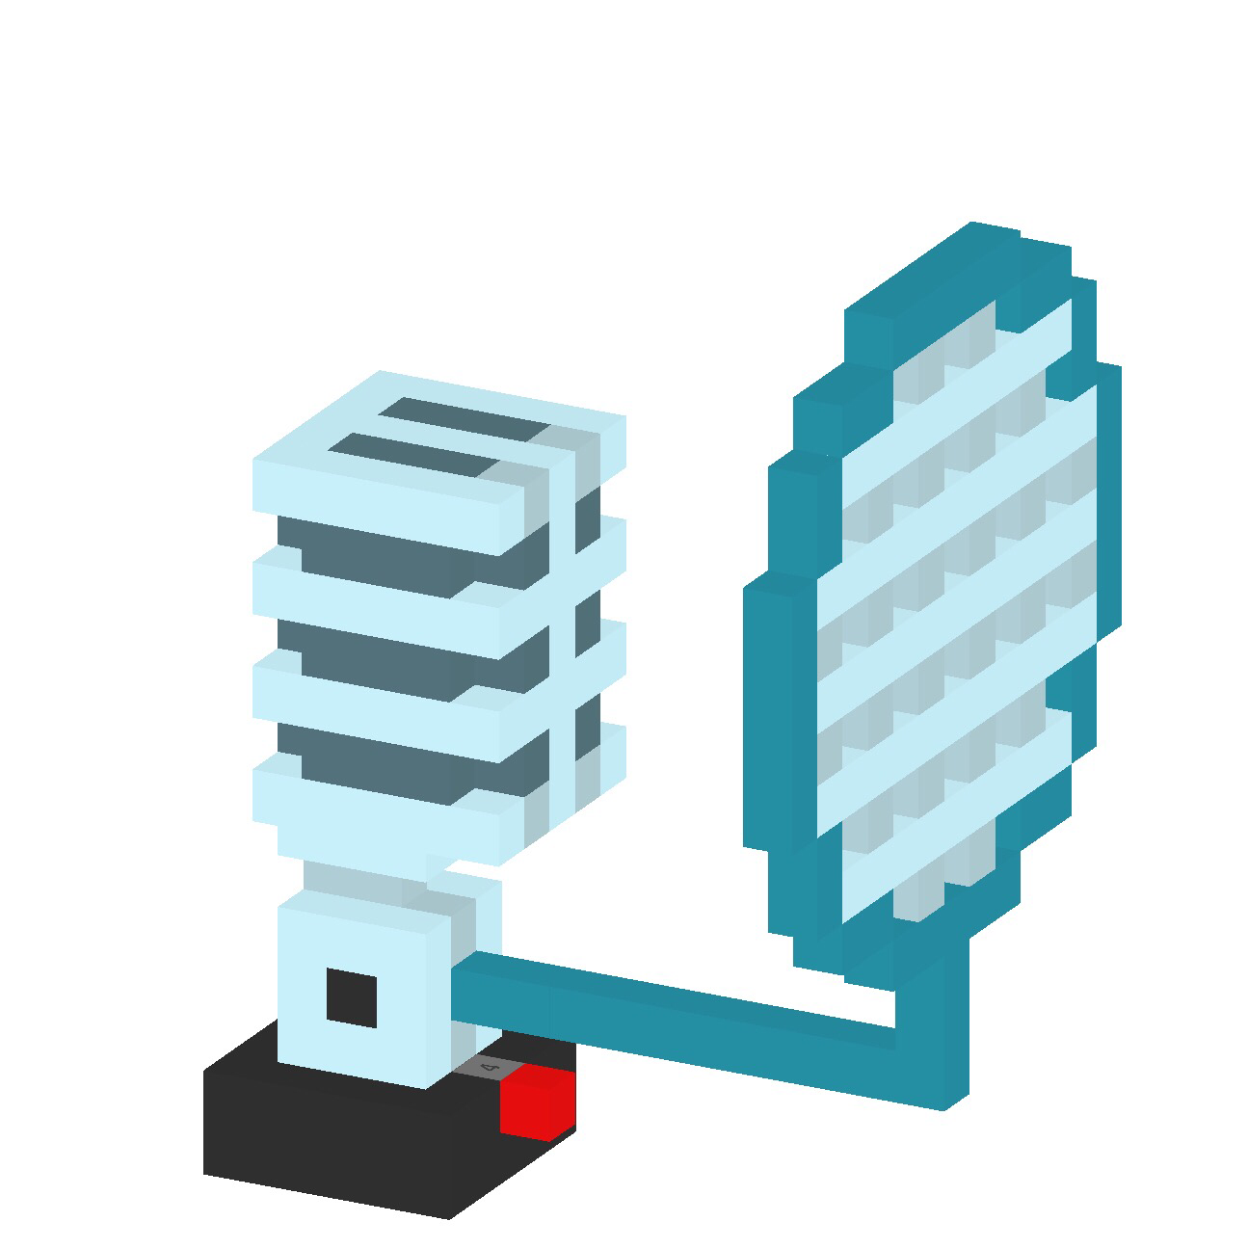

I

